Menu

Appetizers
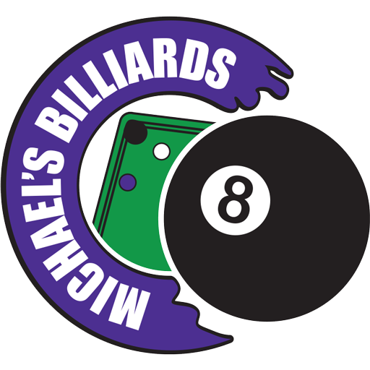
Funnel Fries ….………………………………………………..3.75
Mac ‘N’ Cheese Bites ………………………………………..5.00
Jimmy Dean’s breakfast sandwich ………………………3.75
Fried Pickles …………………………………………………...5.00
Soft Pretzel with cheese…………………………………….4.75
Mozzarella Cheese Stix …………………………………….6.75
Jalapeño Poppers …………………………………………….5.00
French Fries, Potato Wedges – or- Buffalo Tots …….3.50

Add some flavor to your appetizer or entree ……………….. 0.75
- Chili
- Cheese
- Jalapeños
Entrees
Entrees served with your choice of ruffles or Fritos and sauce of your choice
Add Fries, Potato Wedges or Buffalo Tater Tots to your order for 3.50
10” Digiorno Pepperoni pizza …………………………………………………………… 11.00
Michael’s Deep Dish pizza ……..………………………………………………………… 11.00
Michael’s Personal thin crust pizza ……………………………………………………. 10.00
Southwest Chicken Rolls …………………………………………………………………….6.75
4 Pc. Chicken Tender …………………………………………………………………………6.75
Chicken Wings -or- Hot wings ……………………………………………………………. 6.75
½ Lb. Angus Cheeseburger ……………………………………………………………….. 6.50
½ Lb. Angus Burger …………………………………………………………………………. 5.75

Burger Fixins’:
- Ketchup
- Mustard
- Mayo
- Lettuce
- Tomato
- Onion
- Pickle
Dipping Sauces
Extra sauce is .75
- Ranch
- Montgomery Inn BBQ
- Honey Mustard
- Ketchup Mustard
- Chipotle Ranch
- Hot Sauce

Snacks

Chips …………………………1.50
Candy ………………………..1.00
Nachos ‘N’ Cheese ……….5.00
Add Jalapeños……………… .75
Peanut butter crackers…...75
Fruit Bars …………………… .75
Cheese Its ……………..…... .75
Hot Dog & Chips ……..….1.50
Jumbo Hot Dog & Chips…3.50
Corn Dog & Chips …………3.50
Danish ………………………..1.50

Drinks
20 Oz. Fountain Drink ………………………………………….. 1.50 ( Refills only $1 if you SAVE your cup! )
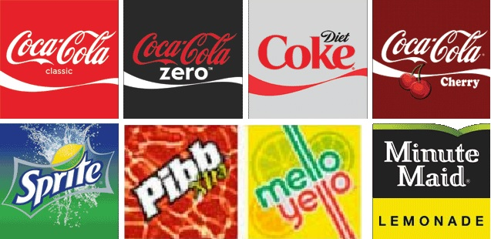

Hot Drinks: ……………………….. 1.00
- Coffee (Unlimited)
- Hot Tea
- Decaf Coffee
- Decaf Hot Tea
- Hot Chocolate
Bottled Water …………………….1.25
Canada Dry Ginger Ale ……….. 1.00
Tropicana Juice ……………………. 2.00
- Apple
- Grape
- Cranberry
- Orange
Gold peak Tea ……………………… 2.75
- Sweet & Unsweet

