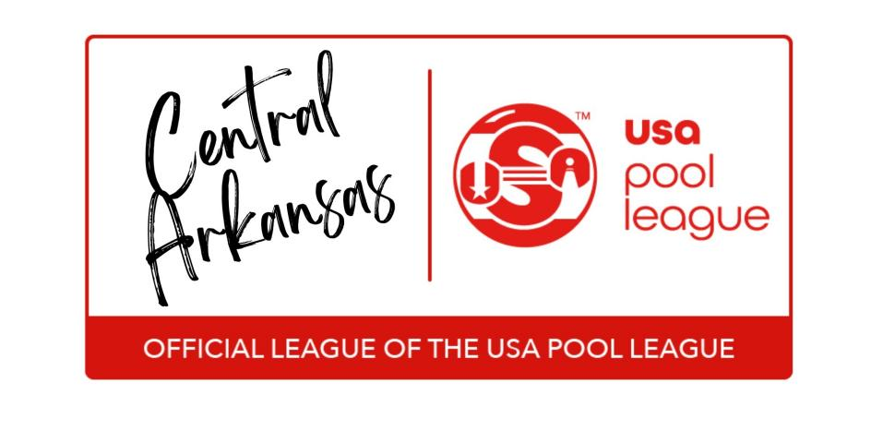

These bylaws are official rules of the Central Arkansas USAPL and override any rule as it is written in the USAPL Rule Book, if there is a difference between the two. **All players are responsible for knowing these rules.** The Central Arkansas USAPL Office has the final say on all League rules and rulings, as well as all matters concerning the operation of the league. The Central Arkansas USAPL Office also has the right to refuse, suspend or terminate membership of any player if the best interests of the league and its players are served. The purpose of this document is to create a complete set of rules that are fair for everyone and to make these rules clear and concise, reducing potential arguments allowing all players to have fun and shoot pool.

1. **Starting Time of Match -** Starting Time of the Match will be 7:00 pm. Each set the two players will lag to determine who breaks in the first game. Break will alternate in all subsequent games. Forfeit time is 7:30pm. Play on 2nd table should not start until 7:30pm.
2. **Procedures for Putting Up Players -** To start the match the 2 team captains flip a coin. The winner of the flip may choose a player to start the match or defer to the other team. The order of choice will then alternate for each subsequent set. Once the first player is chosen, the opposing team will then choose any member of their team to be the opponent. The first team to choose a player may change that player until the second team has chosen a player and the first team informed. Neither player may make a change after that point.
3. **Time Limits for Putting Up Players -** Each team will have 3 minutes to choose or put up a player from their roster.
4. **Duplicate Player on a Team -** Only one player may play twice for the same team on any given regular session league night if a team is short of a player. You cannot opt to forfeit when a team is short one player and can double play. A forfeit can only happen if the team is short of two or more players. The opposing team captain will get to choose which of the players on the “short team will play twice. If a team is short of 2 players, they will have to forfeit one of those sets. The points scored by the duplicate player’s second match will only count on the team’s total points and the player will not get any “MVP” points for his second match. In addition, this second match will not count towards a player’s rating history or count as a “week played” for eligibility in any local, state, regional, or national USAPL tournament or playoffs of any kind.
5. **Match Length** - All formats will use the “longer race” when setting up their score sheet to start the set.
6. **Make Up Matches/Sets -** If both teams agree to play a makeup set or entire match, it must be approved by the league manager and played within 7 days of the original scheduled date of the match.
7. **Bye Weeks -** Byes will not have any effect on the team standings, as team standings will be based on “Points Per Set” average. It doesn’t matter if a team has one or two byes during the session, standings are based on the “Points per Set” average from the weeks played. It is very important for players to play all out to get as many points as possible, regardless of whether they win the set. This will make a significant impact of your “Points per Set” average, as well as have an impact on the total points, which may be a determining factor in tie breaking.
8. **Forfeiting Sets/Matches -** All forfeited sets will score 200 points for the winning player. All forfeited matches will score 1000 points for the winning team (5 player teams). Every effort must be made to make up matches rather than forfeit.

1. **Drop Out Teams -** Teams that drop out during a session can create problems within the league. It can have an uneven or unfair effect on the division standings. Although no one can be forced to pay, a team that has started a session is responsible for the full session’s fees. The captain of a drop out team will not be allowed to play on future league teams until all fees owed are paid in full. Team members other than the captains are responsible for their share of the total fees owed and must pay these fees before being allowed to rejoin the league with any other team. The league manager will try to find a “Replacement” team to fill the vacant spot. If it is not possible to find one, the league manager will be forced to try to find the most equitable and fair way to adjust the league’s team and/or singles standings. Possible methods include “wiping out” some or all of the past matches, converting played matches to byes, and points averaging. The method used may vary depending on which part of the session a drop out occurs. The method used will be at the discretion of the league manager.
2. **Eligibility for Playoffs/Post Season Play -** To be eligible for local singles tournaments, team playoffs, or any post season play, players must have a minimum of 5 weeks of league play on one team, in one division, in a single session, and their team must complete the session. Central Arkansas USAPL’s year will start with the Winter session and end with the Summer session.
3. **Eligibility for the USAPL National Championships - Singles** - To be eligible you must have 8 weeks of play within a single division or 14 weeks of play within the league year. **Teams** – To be eligible, a team must have 2 original members on the team, who must have played 8 weeks on that team, in the same division, in the same session. The other 3 players on the team must have played 8 weeks in a single session or played 14 weeks during the year in the same league number as the originals. If there are only two original members of the team, they will be required to play in the first two sets at the national tournament. If your team has 3 or more original members, you may choose any original member to play in each of the first two sets. (Complete description of requirements is always provided in the current year’s National Player’s Guide).
4. **Rosters Changes -** Players cannot be added to the roster after 6 weeks of regular play unless it is for the survival of the team. The USAPL Manager will determine “Survival” guidelines.
5. **Proof of Identity -** All players must be able to provide proof of their identity prior to the start of a set.
6. **Penalties for Unsportsmanlike Conduct -** Exact penalties will be determined by the USAPL Manager. These penalties may range from a warning to suspension/expulsion from the league, or disqualification from a tournament or playoff.
7. **Slow Play -** We encourage people to have fun, play at a reasonable pace, and enjoy league pool. However, there may be a rare occasion when the league manager will have to rule on slow play. Either player or both players may be put on the 45 second shot clock at the league manager’s discretion.
8. **Playoffs -** Every session (Spring, Summer & Fall) each Division will have a separate playoff with the determined number of finishing teams in the division and one arbitrarily drawn wild card team which is chosen from the rest of the teams in the division. The Wild Card team will be drawn by the League Manager at a prescribed date, time, and location. If any of the team captains wish to attend the “Wild Card” drawing, they are welcome to do so. Ask your league manager for details. Divisions with 6 teams or less, will have 4 teams play in the playoffs. High Point will play the wild card team, 2nd place and 3rd place will play each other. The winner of each will play each other, determining one team as the winner from the playoffs. That team will be qualified for the City Wide Tournament (CWT). In divisions with 7 teams or more, High Point gets an automatic bid to the (CWT’s), and 4 teams will play in the playoffs. The 2nd place team will play the wild card team, and 3rd place will play the 4th place team. The winner of each will play each other, determining one team as the winner from the playoffs which will also go to the (CWT). These numbers may change as the league grows or changes and are at the discretion of the league manager.
9. In order to be eligible for the **City Wide Tournament (CWT)**, teams must play at least 2 of the 3 sessions of the league year. Any team that has qualified for the **CWT** thru playoffs or high point must continue to play, to remain eligible.
10. **City Wide Tournament (CWT)** - The City Wide Tournament will be held at a predetermined date and location determined by the league manager. The CWT will be a true double elimination format. Teams that qualify for the CWT must continue to play or forfeit their spot in the CWT. The CWT will determine which team(s) win a free entry to the National Championships in Las Vegas. Central Arkansas USAPL will pay travel expenses and hotel rooms for one team out of every 12 in each format (e.g., 8-ball, 9-ball, etc.). Any format that has less than 12 teams, Central Arkansas USAPL will pay for as much travel expense and lodging as the prize fund allows.

Thank you for playing USAPL!

Any questions please contact Lisa Orr @ 501-609-6879

Or email - [centralar@playusapool.com](mailto:centralar@playusapool.com)

Updated July 2025